Research:

At least 13,842 deaths were associated with 12 of the world’s deadliest armed conflicts in 2021, including 11,075 civilians. However, civilian deaths dropped by 17 per cent from 2020, and by 69 per cent from 2015.

Global Peace Index 2022 results show that the average level of global peacefulness deteriorated by 0.03%

 Although slight, this is the eleventh deterioration in peacefulness in the last fourteen years, with 90 countries improving, 71 deteriorating and two remaining stable in peacefulness, highlighting that countries tend to deteriorate much faster than they improve.

**The gap between the least and most peaceful countries continues to grow**. Since 2008, the 25 least peaceful countries declined on average by 12.1%, while the 25 most peaceful countries improved by 4.3%.

Each year, more than 1.6 million people worldwide lose their lives to violence

**The right to peace in UN Human Rights Council**

Two billion people lives in conflict-affected areas, according to the United Nations.

Color Palette:

White and black

Fonts:



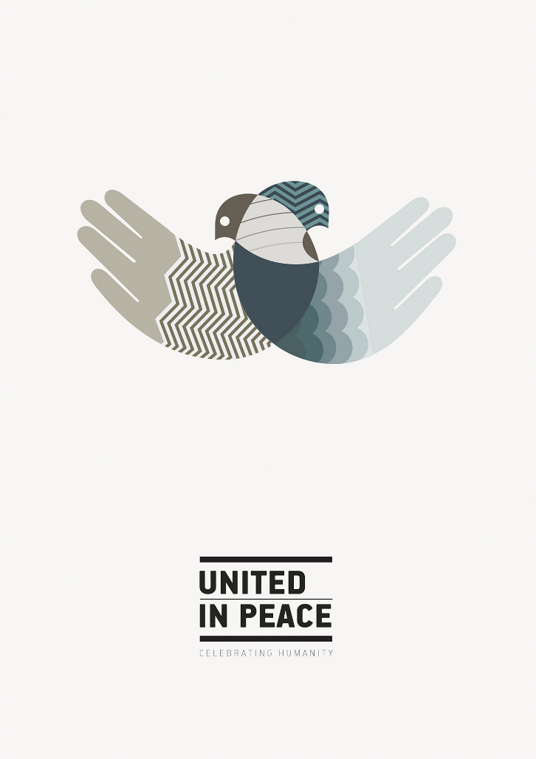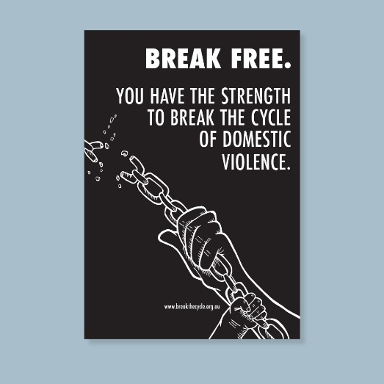Examples:

